Gorge Handweavers Guild WeGO Report Fall 2022
prepared by Kathy O’Hern

Our guild has resumed in-person guild meetings with a ZOOM option.

Weaving Showcase – we have set up a display to showcase our work in the Grace Carter Studio, where our guild meetings are held. The first showcase is to show our last challenge project, which was to weave something using one of the National Park color palettes.

Member Spotlight – a guild member is interviewed and asked questions about her/his weaving background. When and why they began weaving, what they like to weave, what kind of loom, etc. This is shared with the entire guild through our communication platform – groups.io.

Weaving Tips - one of our guild members is providing a weaving tip each month. September’s tip was different methods of hanging floating selvages.

Challenge project – weave any type of bag using ANWG 2023 conference colors. Due in May 2023.

Monthly raffle – each month there is a raffle at the end of the guild meeting. Items for raffle are “stash” items brought in by guild members.

Planning our guild display for the ANWG conference.

Robyn Spady Workshop – A Parallel Threading is the Weaver’s Playground, 3-day workshop October 15-17, 2022. This workshop partially funded by and ANWG grant.

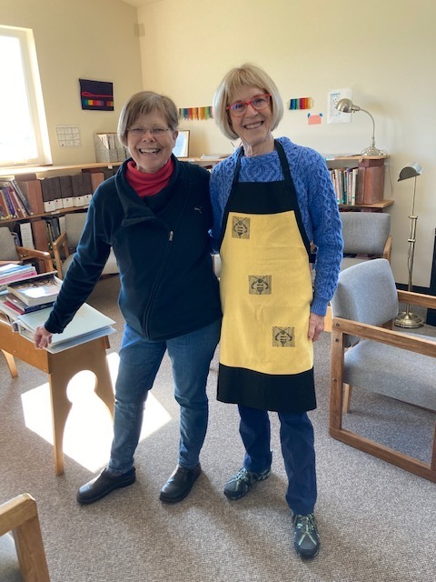
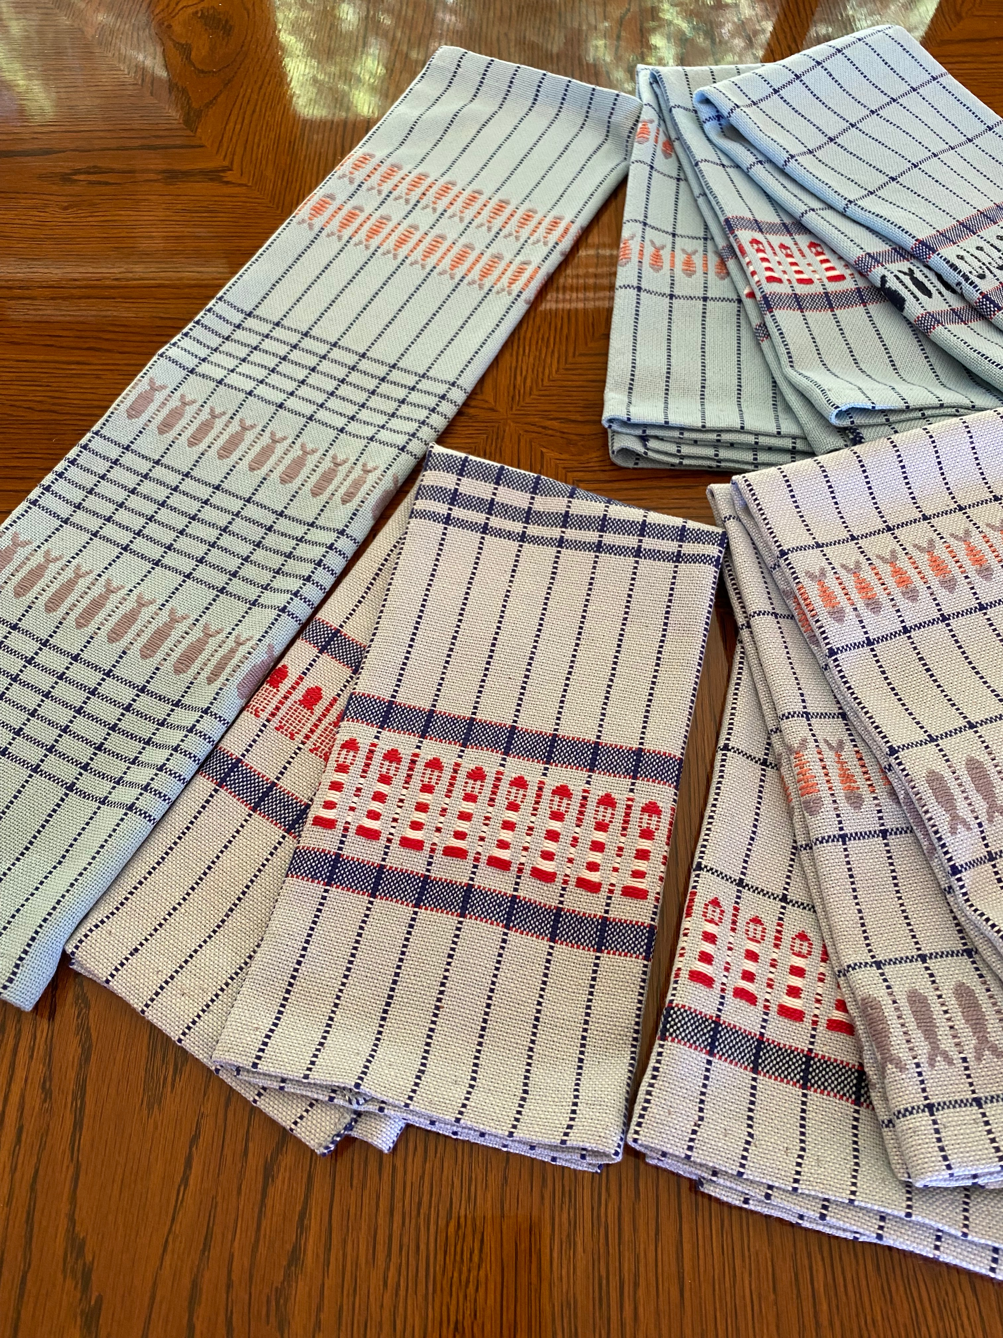
Photos of member weavings

Towels and Bee Fabric woven by Ruth Dye.

Apron:
The warp was 8/2 cottolin peach with 8/2 cotton pale yellow. The weft was 10/2 pearl marigold cotton and 5/2 pearl cotton black. Summer winter structure using pickup for inlay bees. Sett 20epi

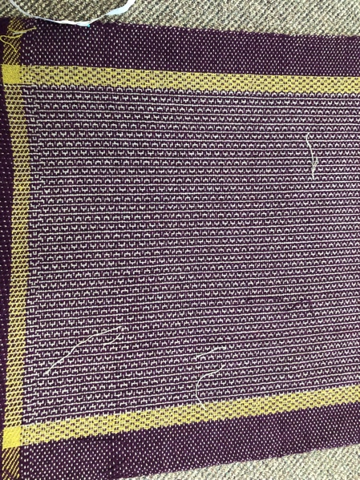
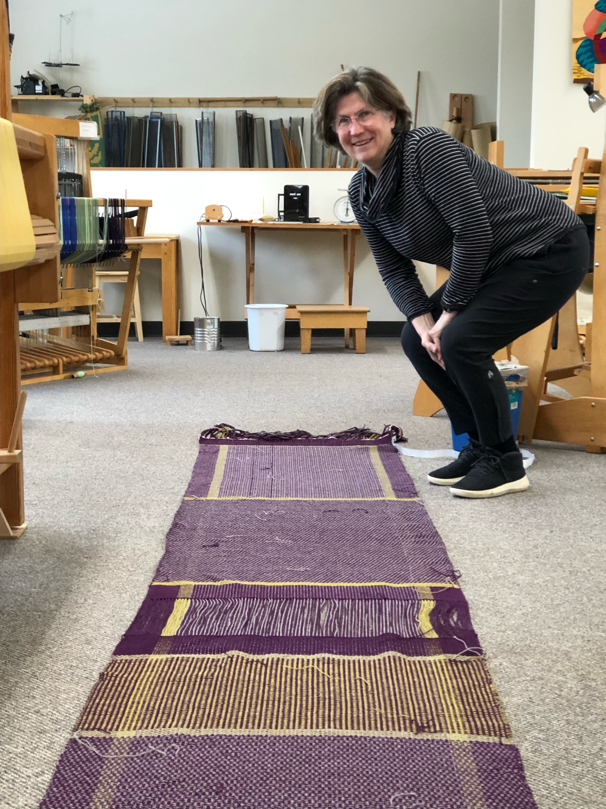
Kathleen Dalke's shawls are basketweave and 3/1 twill wool. Pattern Jane Stafford

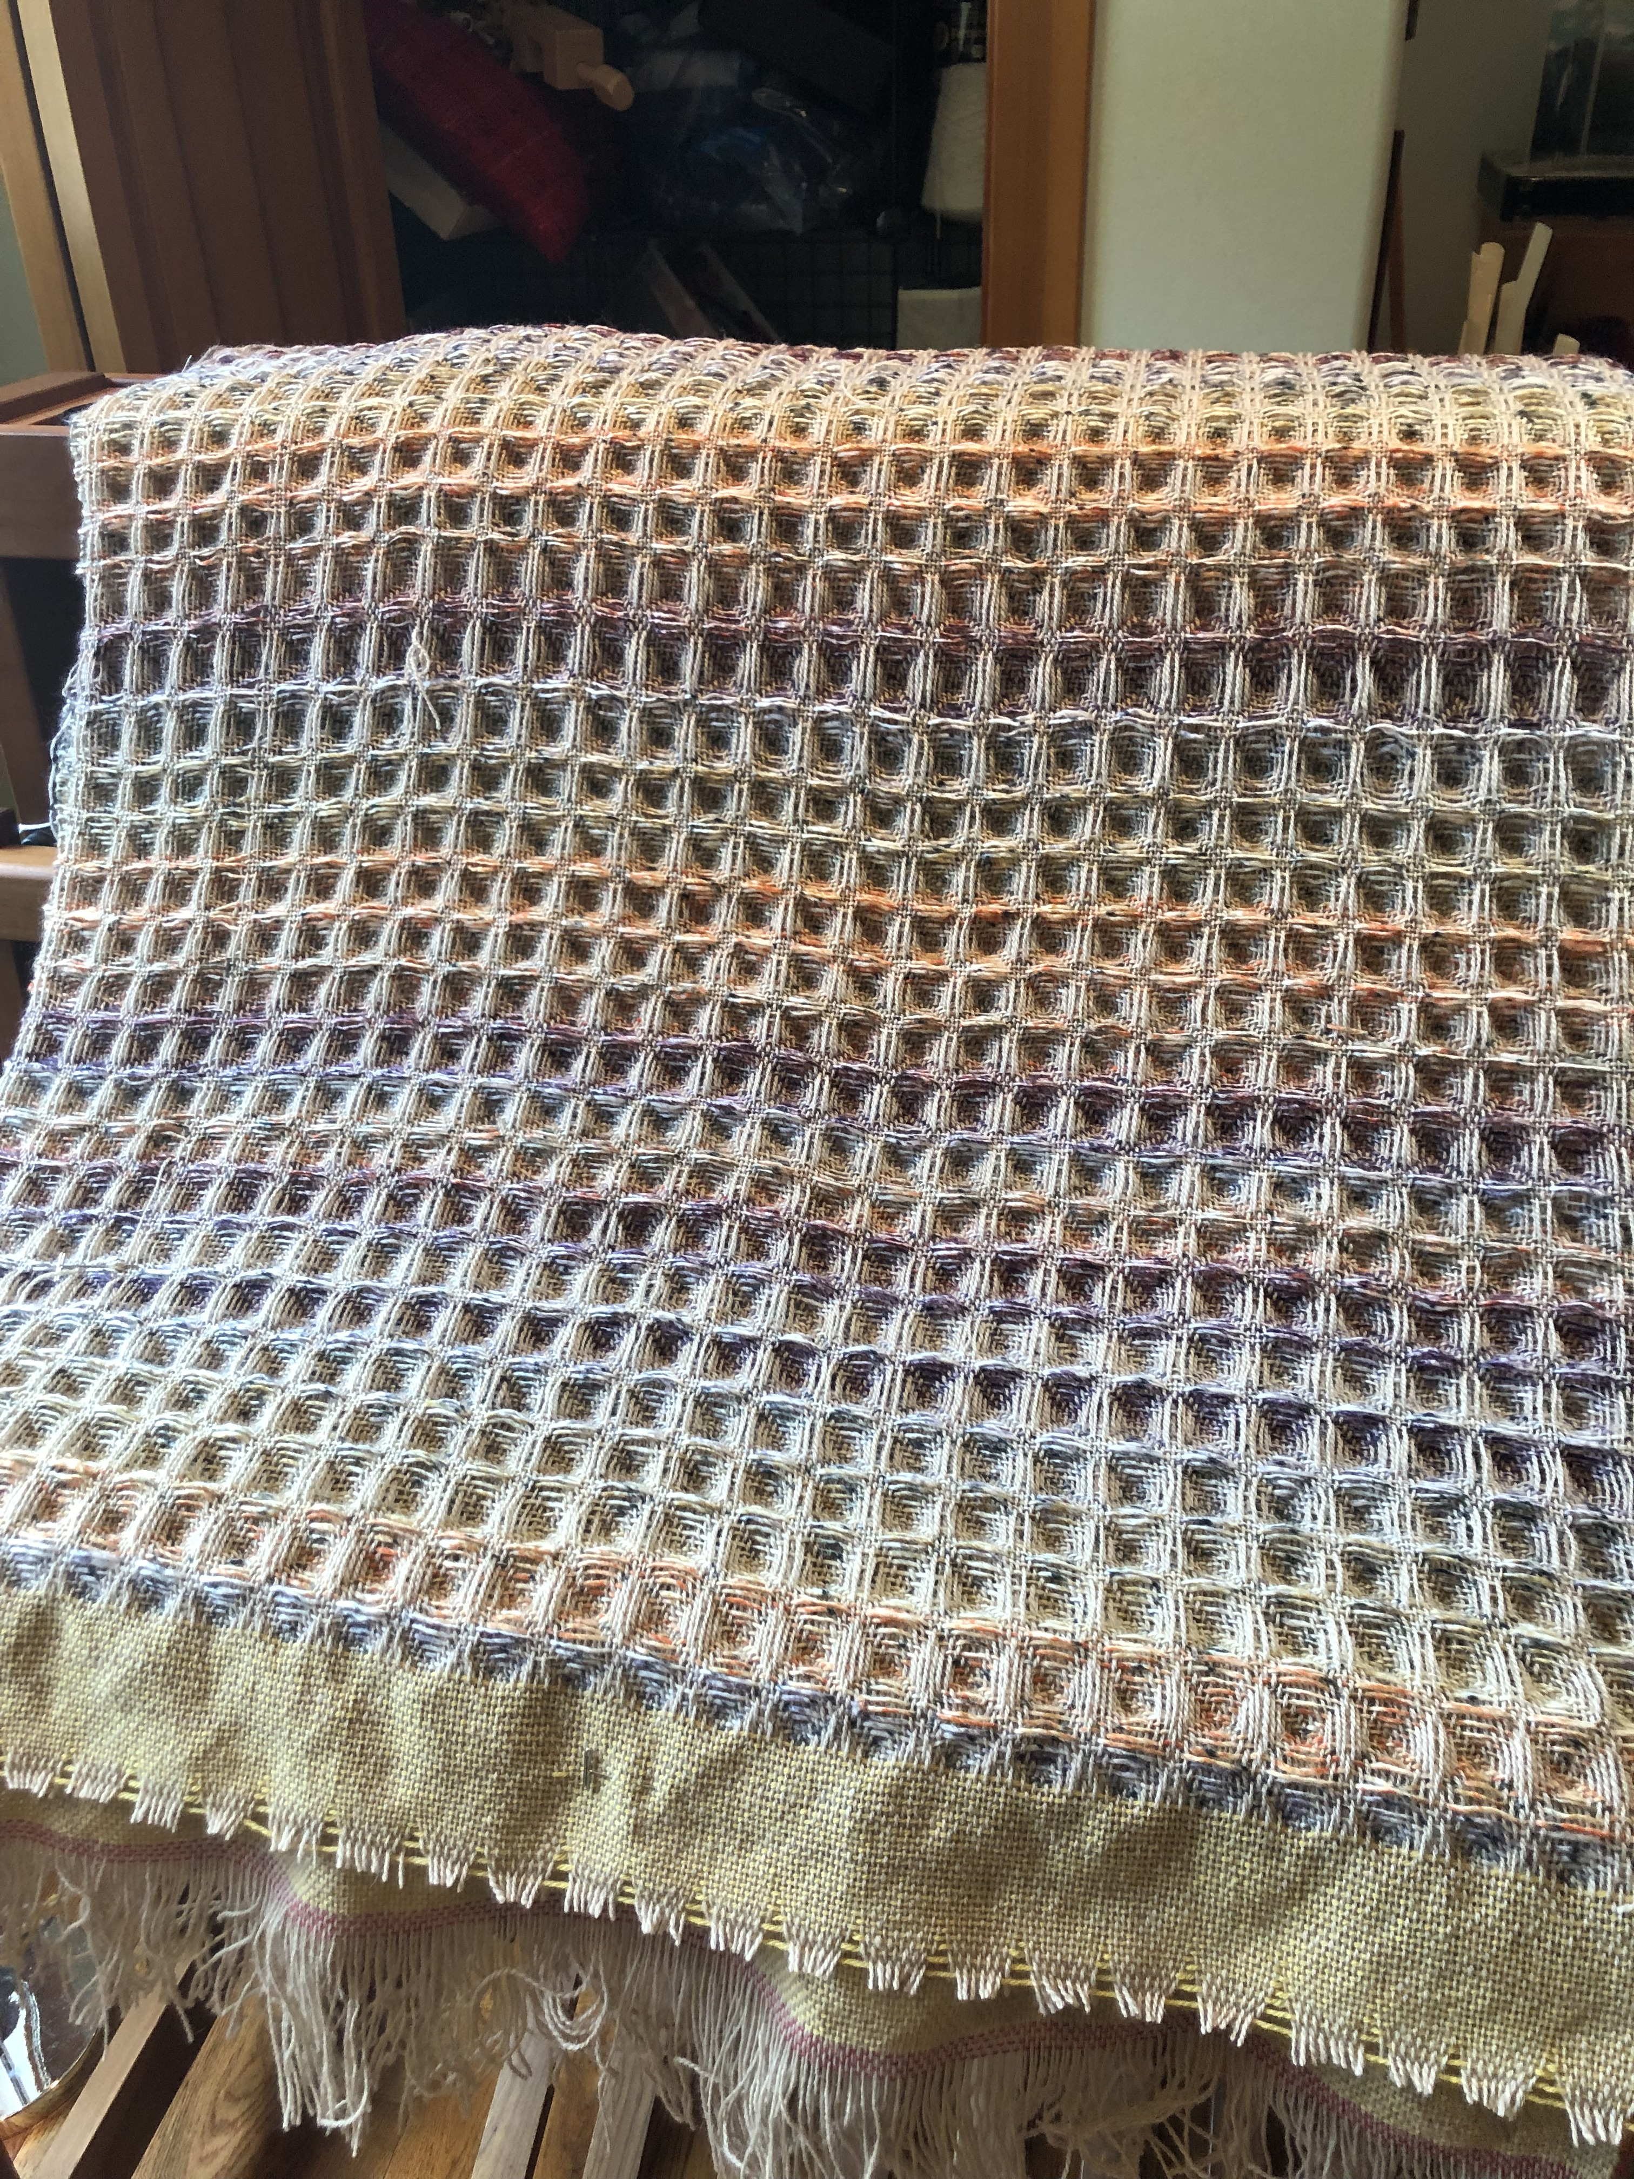
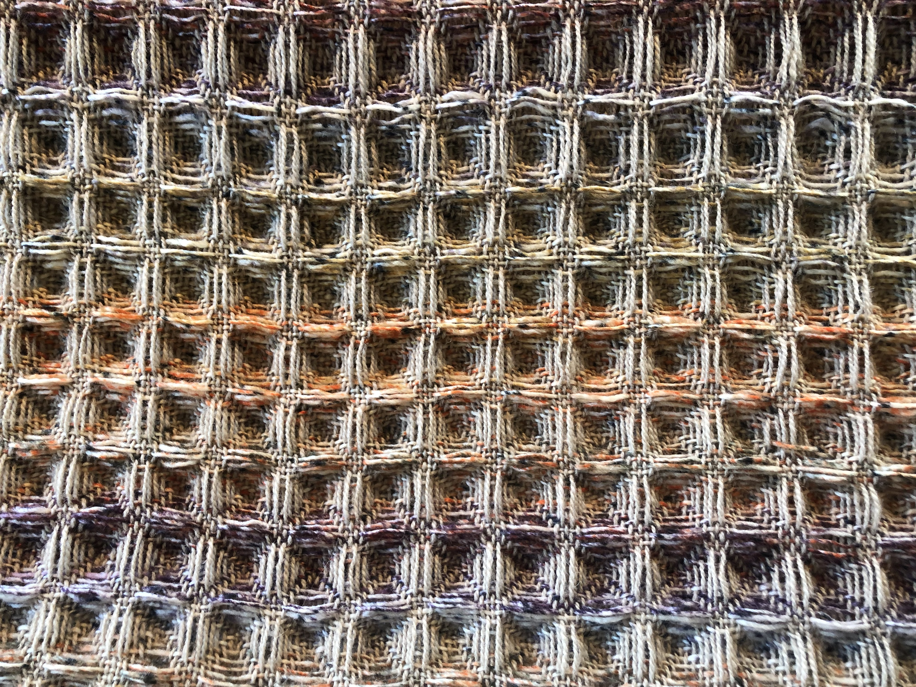
Waffle Weave in wool by Shari Trout.

