Web Foot Weavers & Fiber Artists Guild
Fall 2022 Guild Report to WeGO
Submitted by Vanessa Damron

The Web Foot Weavers and Fiber Artists Guild normally meets the first Wednesday of each month, with the exception of the month of July. JoAnn Sutter is the President and Treasurer of the Guild. Dolores Ebel is the Secretary.
April 2022 Meeting
The 2022 Guild Budget and Calendar was discussed and approved. The schedule is as follows: May: WeGO Scholarship Project dye day; September: bead Leno demo; November: bead Leno; December: annual cookie and cloth exchange.
WeGO Scholarship Project
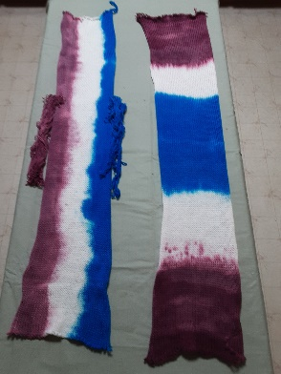
The members approved the WeGO Scholarship project schedule. It was previously decided the project would be to dye knitted sock blanks and create something from the resultant dyed yarn. Patty Beckmann, who is the instructor for the WeGO scholarship program, presented examples of 2 dyed blanks and 2 woven samples from one of the dyed blanks.
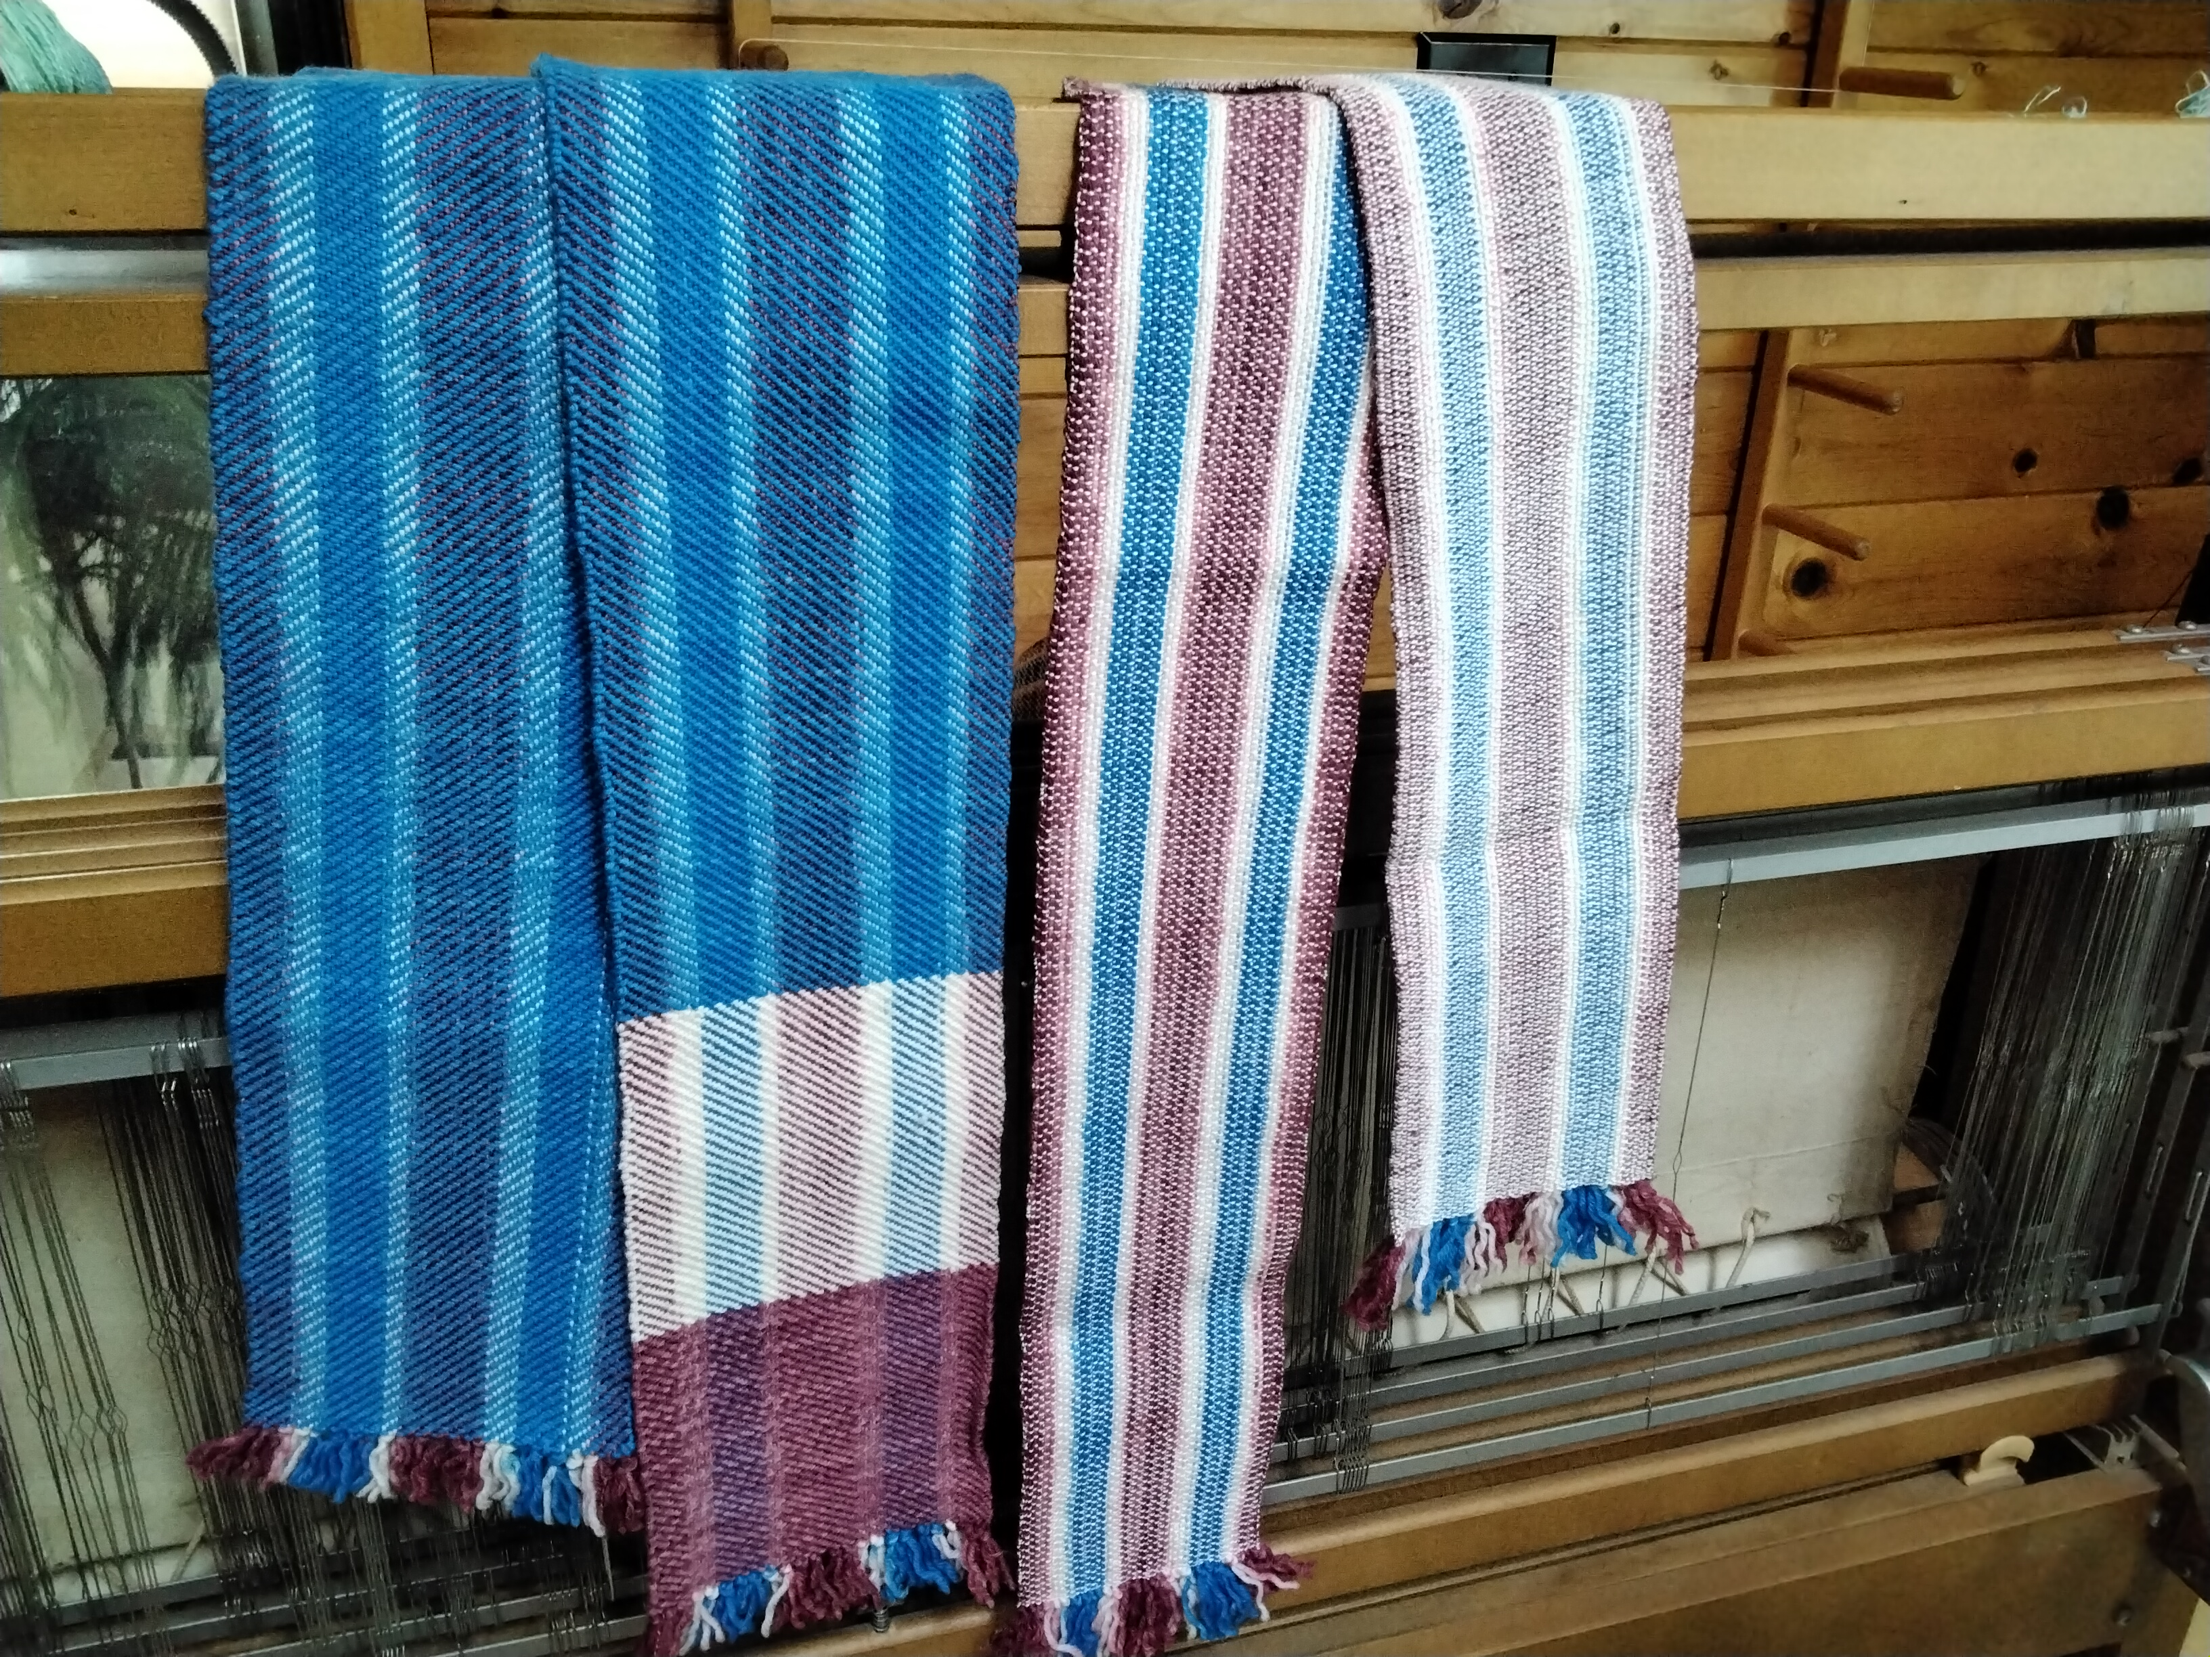

2022 Guild Challenge
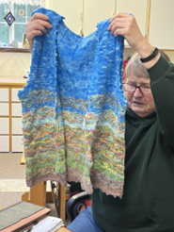
The 2022 Guild Challenge is to create something inspired by nature using at least 3 colors. As an example, Patty Beckmann shared two of her previous projects inspired by nature. One was a knitted vest. The other was a woven scarf.

April Show and Share
Gretchen Green shared her scrumptious Twill Good Vibrations Towel.
Draft: Good Vibrations Towel from Valley Yarns, Draft #218.
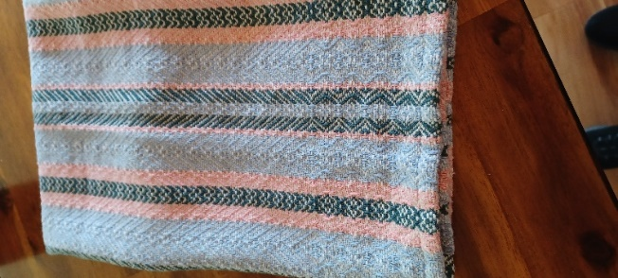
Yarns:
Warp: 8/2 unmercerized cotton Peaches 'n Cream, Black Forest, & Heather
Weft: 8/2 unmercerized cotton Natural
EPI: 24 EPI (2/dent in 12-dent reed)
PPI: 20 ppi.
Weaving Width: 24" minimum weaving width.
Finished size towel: is 19.5" x 23".

Dee brought her Noa coat sample and JoAnn showed her towels with black inlay.
May 2022 Meeting
Dye day was postponed due to an injury Patty Beckmann sustained. It was rescheduled for June.
May Show and Share
Gretchen Green showed off her new Windhaven band loom and the 13 dishcloths of 6/2 cotton from Bluegrass Mills. She donated 4 to the Pistol River Friendship Club to be auctioned to support their scholarship fund. Patty Nance shared the blanket she knitted from left over sock yarn. It was 350 stitches wide! Dee continues to work on her Noa coat for the 2023 ANWG conference in Bend. Joann described the process she used to weave her 8/2 unmercerized cotton plain weave fingertip towels with inlay. She also showed the scissor holders she made from squares woven on a pin loom.

June 2022 Meeting
Meeting was cancelled.
July 2022 Meeting
The members discussed and agreed to participate in the Christmas in July Bazaar sponsored by the Pistol River Friendship Club. Two members will demonstrate weaving and four members will bring items to sell. The Webfoot Weavers Guild will donate a basket to be raffled off with the proceeds going to the Pistol River Scholarship fund.
Members agreed to change the meeting location to the Curry County Library in Brookings.
Eight guild members dyed their sock blanks for the WeGO Scholarship Project. Please see the WeGO website for photos and description of the project.
August 2022 Meeting
Members discussed the 2023 Bend, Oregon WeGO sponsored ANWG conference. Everyone is waiting for additional information on everything from the towel exchange to the Noa coat challenge.
August Show and Share
Members who participated in the July sock blank dye day brought their dyed yarn to share. The yarn looked much different after the blanks were unraveled and wound into skeins or balls.
September 2022 Meeting
Joann Sutter presented a workshop on regular Leno. She had 2 table looms warped and stick shuttles ready for members to experiment with Leno. Joann will provide each participant with their sample at the next meeting.
October 2022 Meeting
The business portion of the meeting was held at the Curry County Library in Brookings, OR. The members then moved to Patty Beckmann’s studio for the day’s presentation on processing sheep and alpaca wool. Patty explained how to skirt a fleece and demonstrated washing, picking and carding of the cleaned fleece. She also showed and explained the differences between the fleeces she has recently washed, as well as various breeds of sheep, alpacas and a llama.

