Aurora Colony Handspinners Guild (ACHG)
WeGo Report for the period April 1, 2023 to September 30, 2023

ACHG meets on the fourth Thursday. Most regular monthly meetings are held at 7:00 p.m. every 4th Thursday (June and September meetings are subject to change. Please check the website calendar for current dates and times). In April, July, and December there are no monthly meetings but there are other events. There is no meeting in November.

April

Membership Meeting
Lois Olund of Blakesly Creek Farm in Wren, Oregon created the Sheep Breed Study Box to explore sheep breeds and their wool from around the world. This two-year project culminated in a box available for purchase that contains wool prepared for spinning from 131 different breeds of sheep! Lois raises Wensleydale sheep on her farm and has been active in establishing the breed in the USA. She is a retired special education teacher, and a spinner and weaver.
Jane Herbst is a fiber artist with over 40 years of experience who created an award-winning tapestry utilizing yarn samples spun from every breed in the Sheep Breed Study Box. Jane lives in Corvallis, Oregon, and creates art for the Teal Artist Cooperative.

May

Membership Meeting
Fiber Challenge Show and Tell
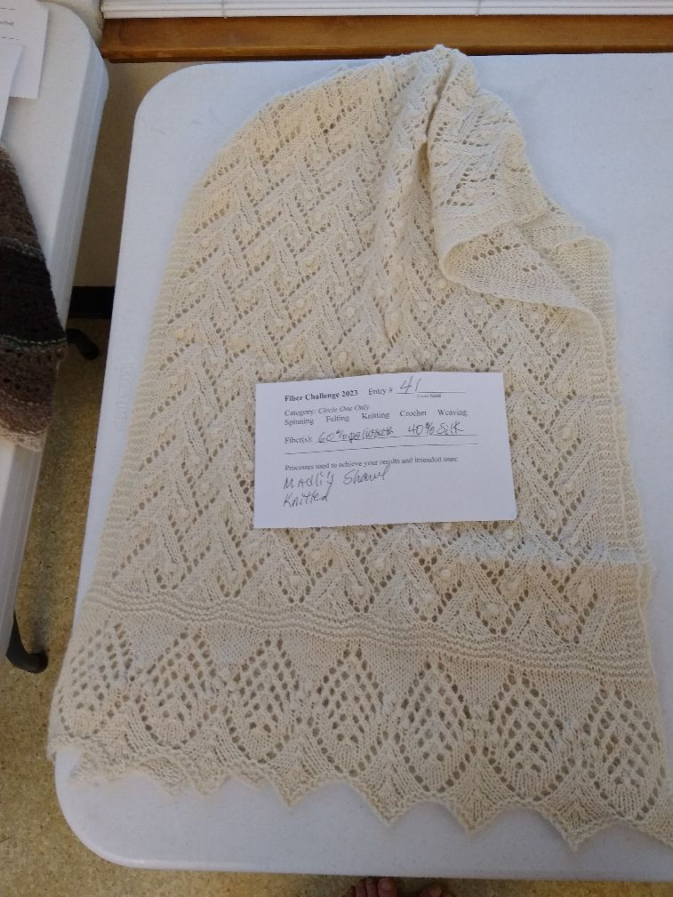
The annual guild Fiber Challenge kickoff took place at the January meeting. This year there were several fiber options to choose from. Wool options include Jacob, Black Welsh Mountain, Manx Loaghtan, Shetland, Gotland, BFL and Polwarth. This year we also had a non-wool option – Flax. All 4 oz fiber bags were $5.
We had so many entries! There’s so much amazing skill and talent in our guild.
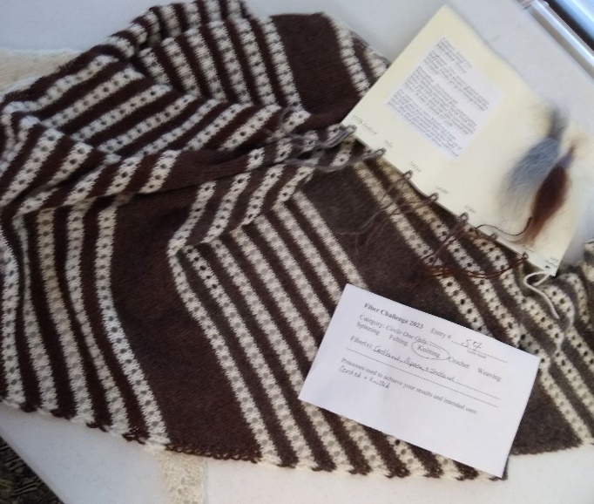
We had two winners in the knitting category. Jane Turville blended her Polwarth with silk and used a pattern from Knitted Lace of Estonia to knit this lovely white shawl. ←
Our other winner was Nicole Crull with her Gotland, Shetland and Alpaca striped shawl. It really made the most of the natural colors. →
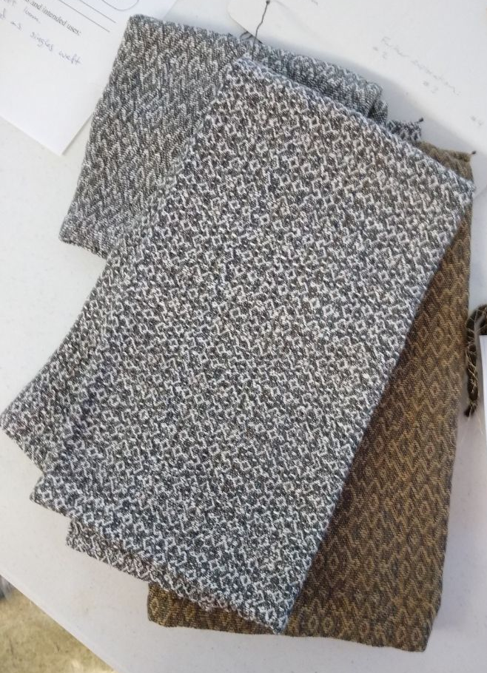
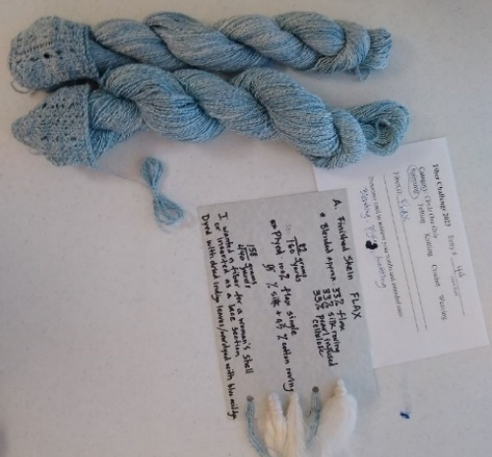
←Best skein went to Becky Smith who told of her challenges with fresh leaf and dried leaf indigo dyeing on her flax challenge fiber.

Best woven went to Hillary who spun flax, and then wove a fancy twill on 8 shafts for these towels. →

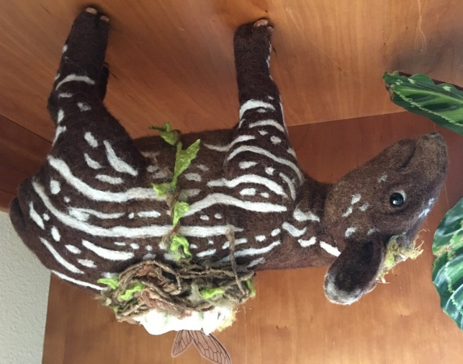
←Dana Nishimura was the felted category winner with a beautiful needle felted Tapir with an adorable little fairy in a nest on its back. She used Manx Loaghtan Wool.

June

Membership Meeting
Destash Sale and spinning circle – our usual meeting was moved to accommodate members who were attending the ANWG conference and Black Sheep Gathering. Members brought items to destash and enjoyed a purely social ‘meeting’.

July

Event: Dye Day
Our annual Dye Day was held as always at the Aurora Colony Museum. Mary Devlaeminck and Kristy Hewitt organized the event. Judy Anderson presented information on Gradient Dyeing.

August

Membership Meeting
Donalee, Kyra and Robert Rodger of Rodger Family Farm and Little Blue Fiber Mill will give a presentation on Shetland sheep, their farm and their processing mill. We missed them in February when we had to cancel our meeting due to weather.

September

Event

Fall Workshops
We had several fun workshops taught by local teachers. Learn to Spin with Loyce Ericson, Spinning 201 with Sheila January, Carding Art Batts, followed by spinning Art Batts, both with Diane Windred, Darn Pretty (mending) with Sivia Harding, and Entrelac Knitting with Backy Smith. We had a nice turnout and had vendor booths and a spinning circle. It was a nice day.

Membership Meeting:
Jean Cockelreas, knitter, felter, hatmaker, production weaver, Fiber Tour Guide gave a two-fold presentation. A presentation on knit to felt. I’m given a lot of wool and I use it often in making hats and slippers. Since hand spinners have lots of lovely wool, this is one way to use it! I’ll also do a presentation video a friend of mine made while we were in Oaxaca on a tour. It beautifully presents the place, its art and its people. I’ll have a few rugs and items I have purchased there over the years as examples to see and touch.

Study Groups:
Knitting Study Group – this year the knitting study group focused on entrelac. Entrelac is a fun knitting technique that results in a diagonal basket weave pattern. It is even more fun if you can knit from right to left as well as left to right for short areas without turning your work

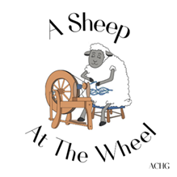
Sheep to Shawl -
We have had a very successful year of Sheep to Shawl demos and even a competition. Our Sheep-to-Shawl (STS) Study Group is Team A Sheep at the Wheel.

A Sheep-To-Shawl event is a demonstration or a competitive event where a group of spinners and a weaver start with a fleece, card it, spin it, ply it and weave it into a beautiful wearable shawl. The ACHG study group wants to learn about breeds of sheep: what is best to use, and what is available in our area. Our group also wants to learn how to spin and ply for both warp and weft, and to weave as a community and team.

Demonstrations have taken place at Red Alder Fiber Arts Retreat (WA), Sheep to Shawl at the Willamette Heritage Center (OR), The Fat Lamb Festival , and five different fairs this summer. Team A Sheep At The Wheel won the Black Sheep competition this year!

Next up is a virtual competition at the Lambtown Festival. Wish our A-Sheep At The Wheel team luck!

More demonstrations and maybe even a competition or two are planned for 2024 so stay tuned!

Members of ACHG, if they spin or weave (or not) can join the study group. This is a learning endeavor for all members who would like to participate. There are about 20 members, and the meetings are on Sundays.
