Gorge Handweavers Guild
October 2023 WeGO Report

ANWG Conference
In Spring 2023 the GHG was busy preparing for the ANWG Conference.
- Our guild booth displayed weavings from our 2022 guild challenge, which was to weave something inspired by one of the National Parks. Framed National Park posters were hung that aligned with the weavings inspired by that National Park.
- The GHG created the centerpieces for the banquet and fashion show tables. Empty weaving cones were wrapped in conference colors. We included fruit and wheat elements to represent our agricultural region. Thank you to guilds that send empty thread cones for this project.
- Four guild members wove fabric, and then sewed a coat for the Noh Coat challenge inspired by the work of fashion designer Bonnie Cashin.

Photography Class
Our first meeting of the season in September included a presentation about photographing our woven items, which is a challenge. One of our members has a professional photographer friend who taught this very helpful workshop.

Tom Kniseley’s Beauty of Boundweave Video
In October Tom Kniseley’s 90-minute Beauty of Boundweave Video will be shown. In this course, master weaver and teacher Tom Knisely will show the ins and outs to boundweave. Information includes loom setup and equipment, tools, and helpful tips from Tom. Soon you’ll be weaving sturdy rugs, placemats, table runners, and more!

Timberline Lodge Project
Lisa Riversong from the Timberline Lodge approached the 2 Gorge guilds requesting assistance to replenish handwoven yardage used to upholster couches and chairs in their iconic lobby. Many details are being worked out – sourcing the type/size thread to use, appropriate/historical colors, previous drafts used, possible funding sources for purchases, etc. An enthusiastic sub-committee has been formed to work with the Timberline Lodge.

GHG Show and Share Photos
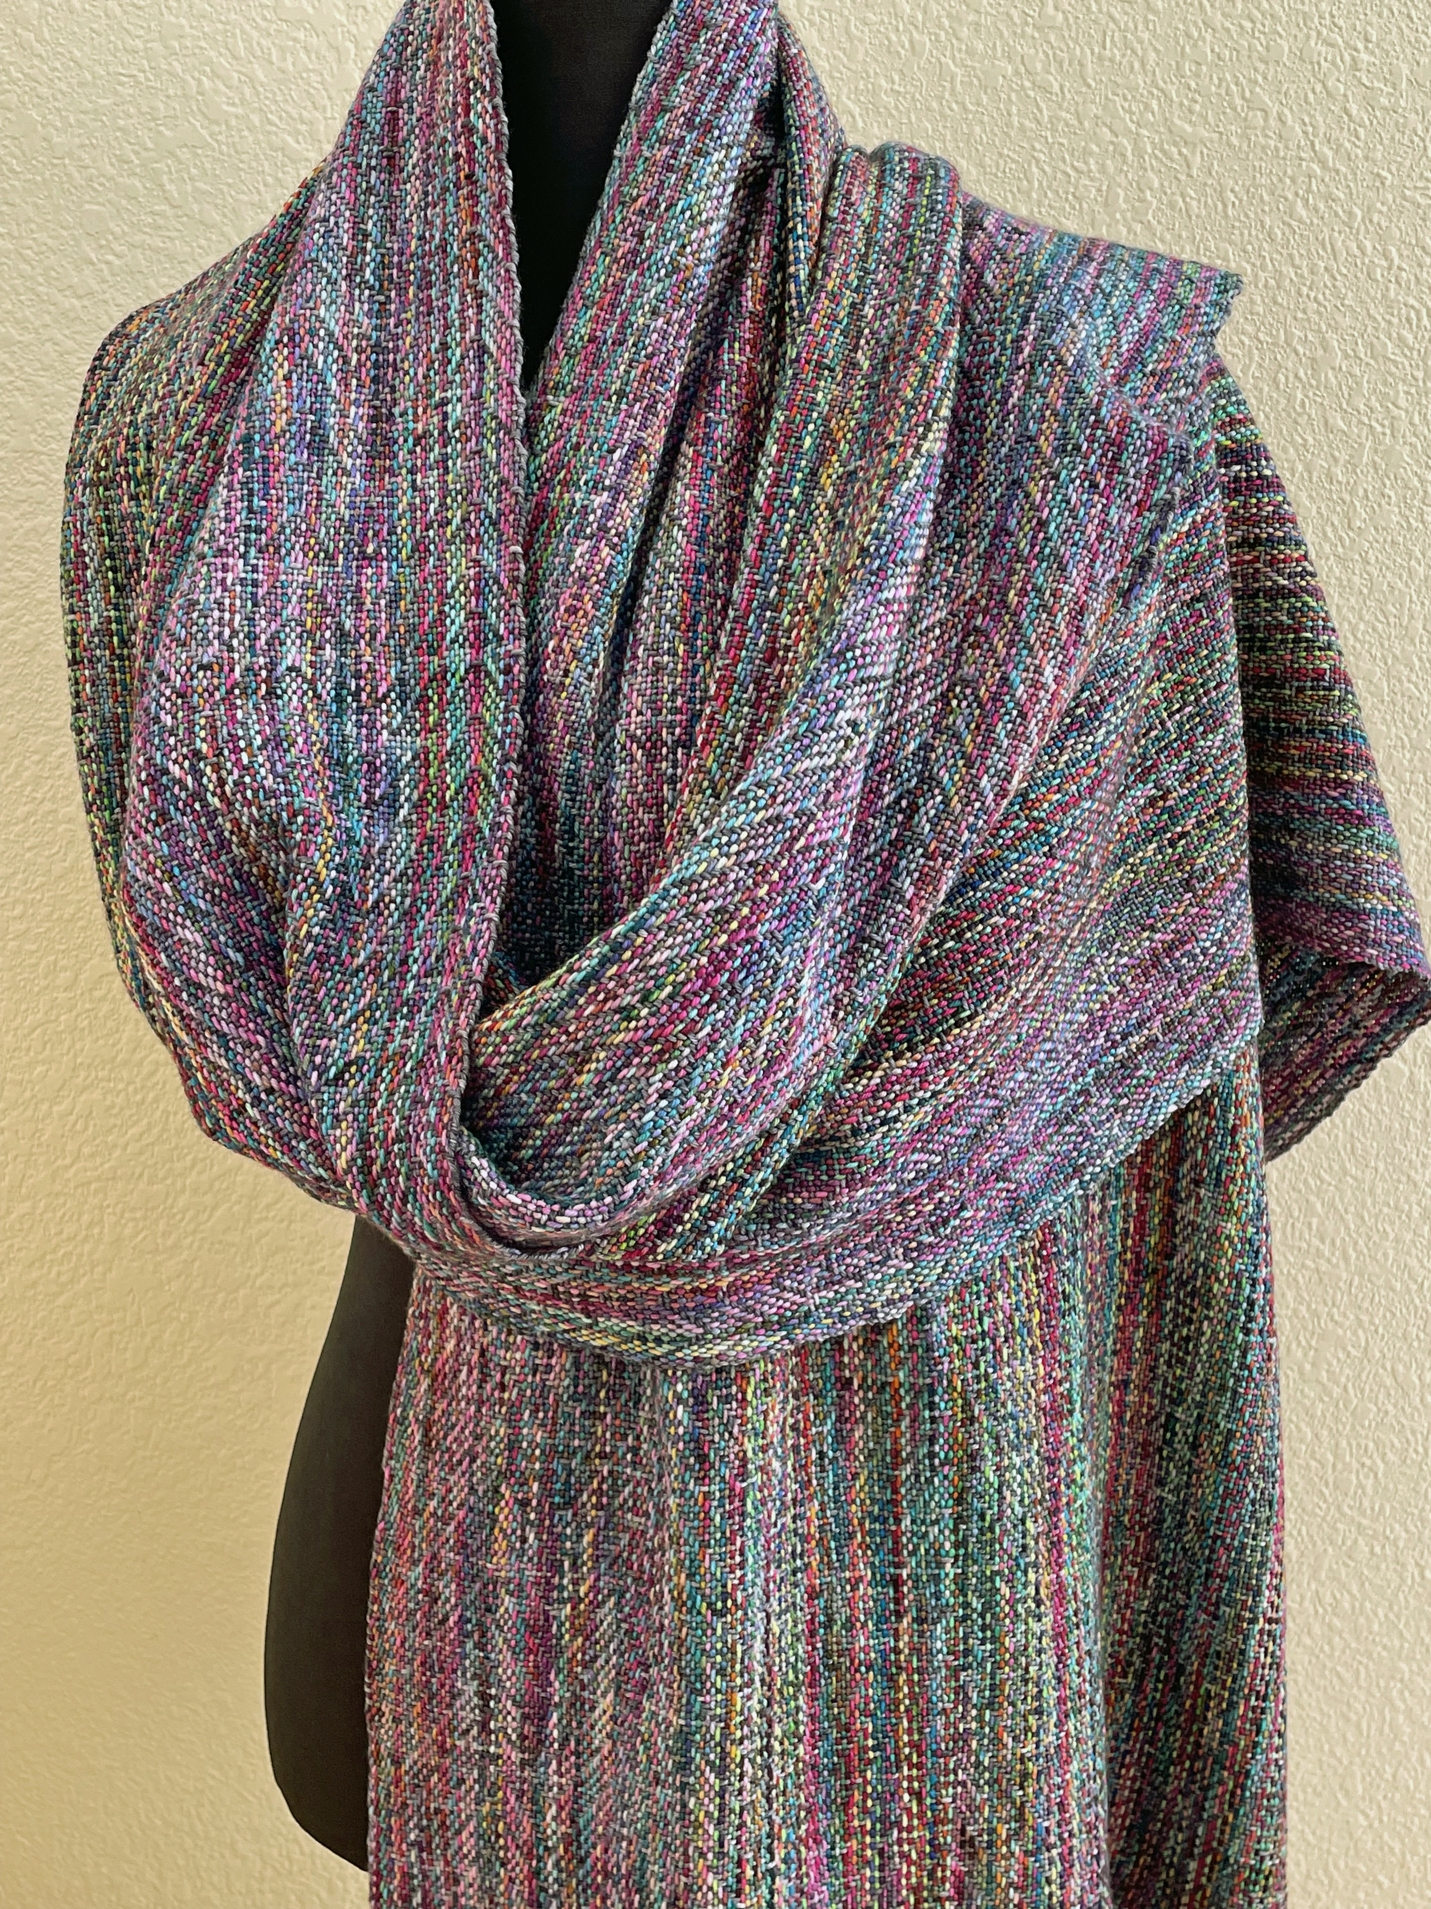
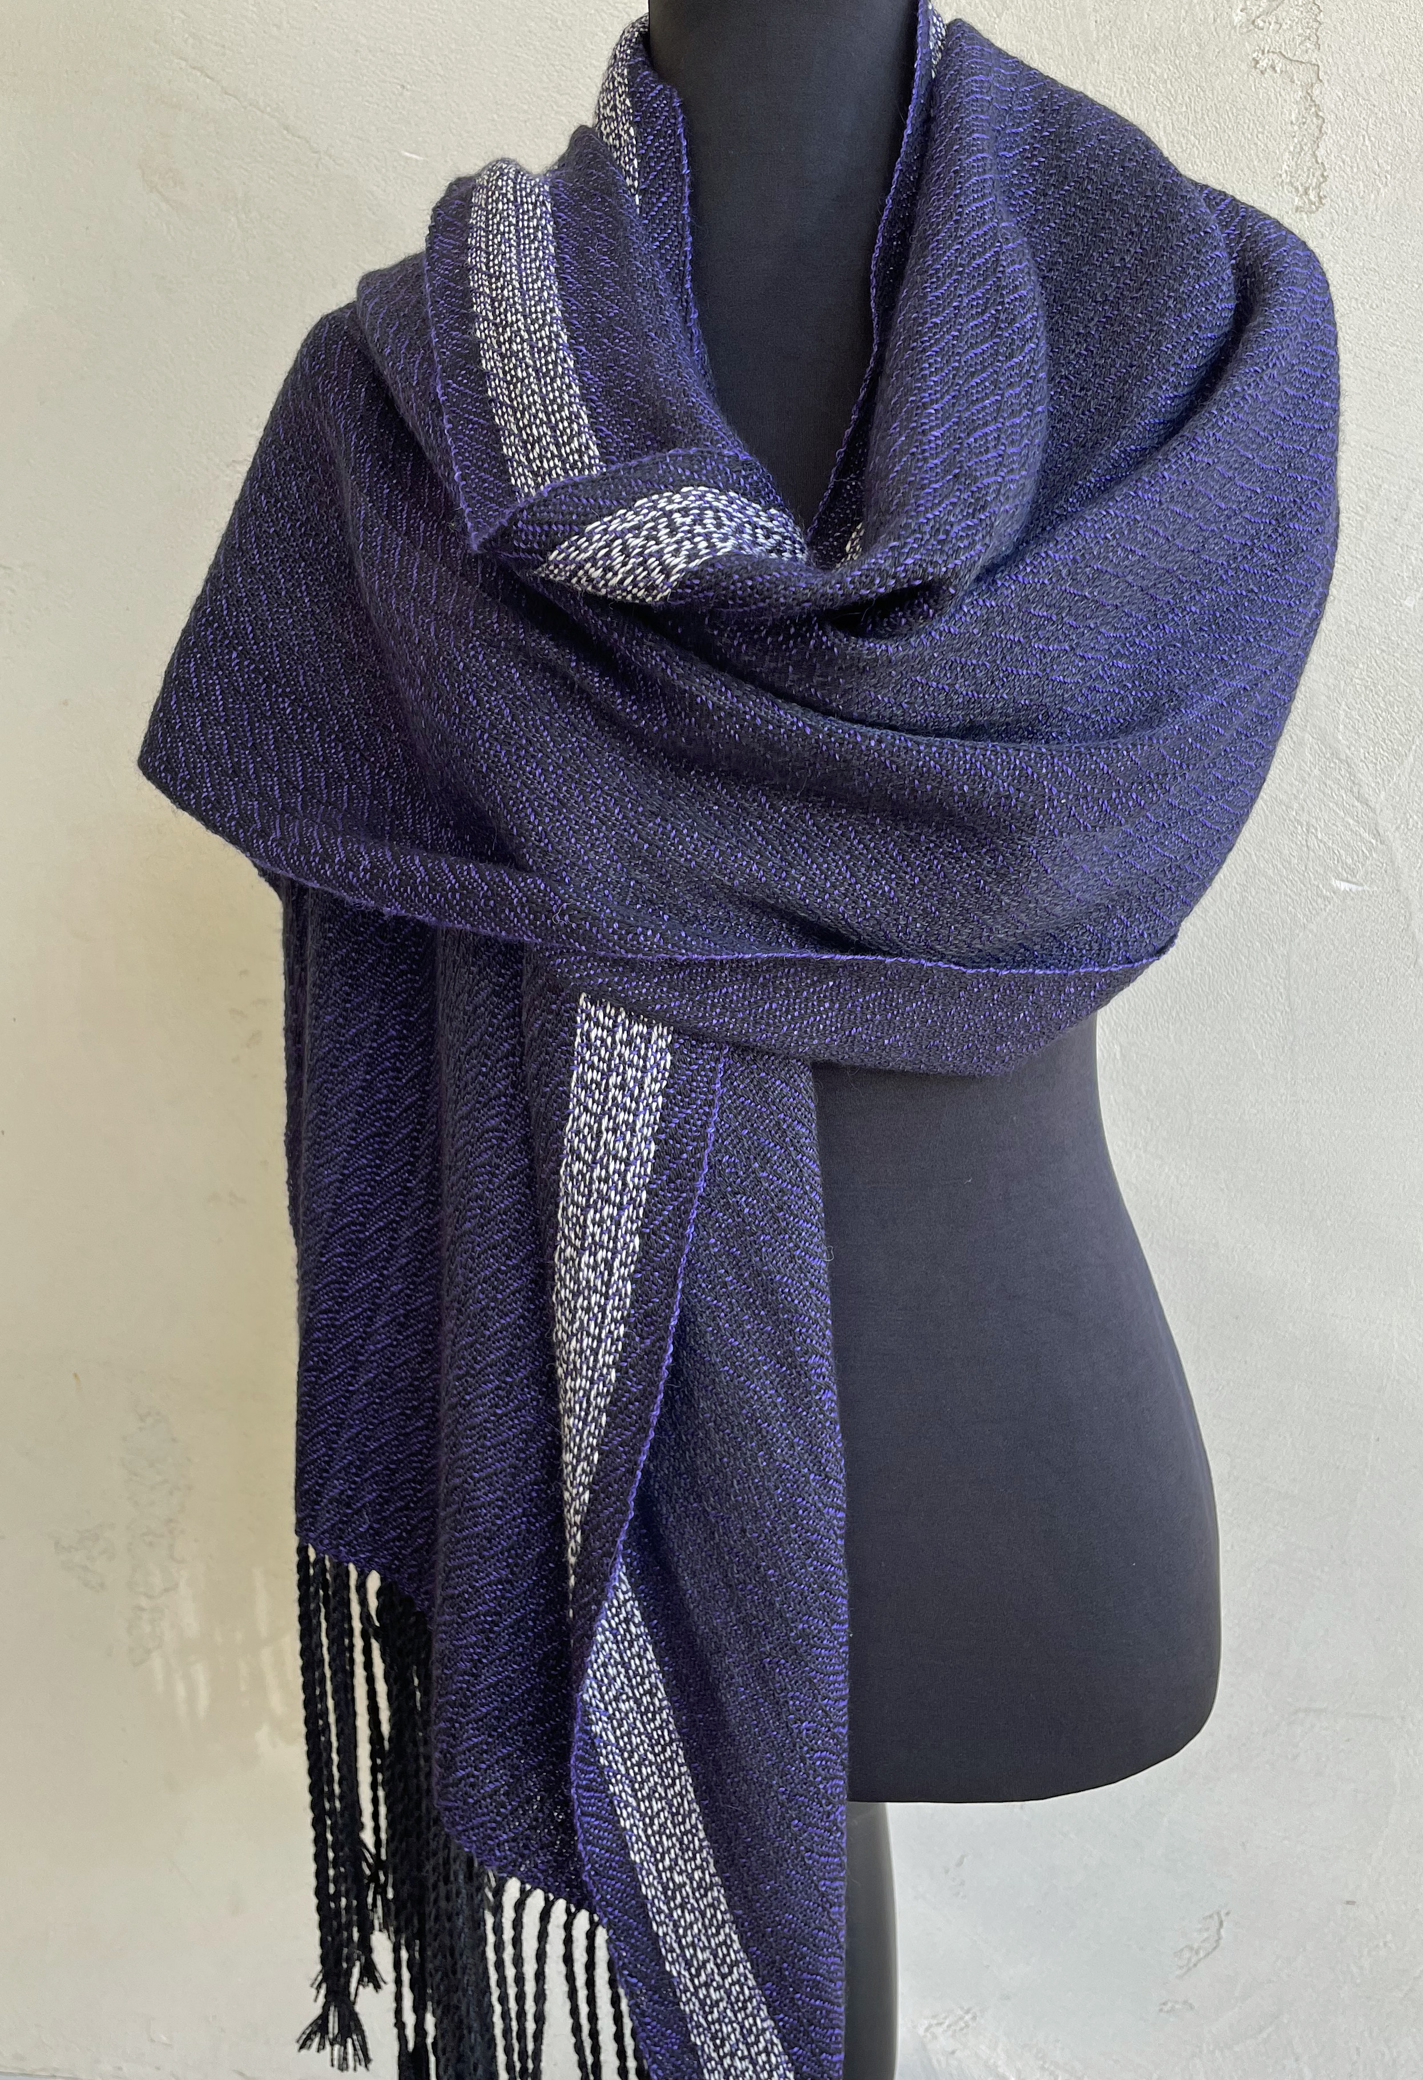
By Ingrid Knox
Hand dyed sock yarn (merino super wash/nylon) for both warp and weft; sett @ 15 epi; structure - extended point twill on 8 shafts.
By Ingrid Knox
Malabrigo Silkpaca Lace yarn for both warp and weft; sett @ 30 epi; advancing twill on 8 shafts

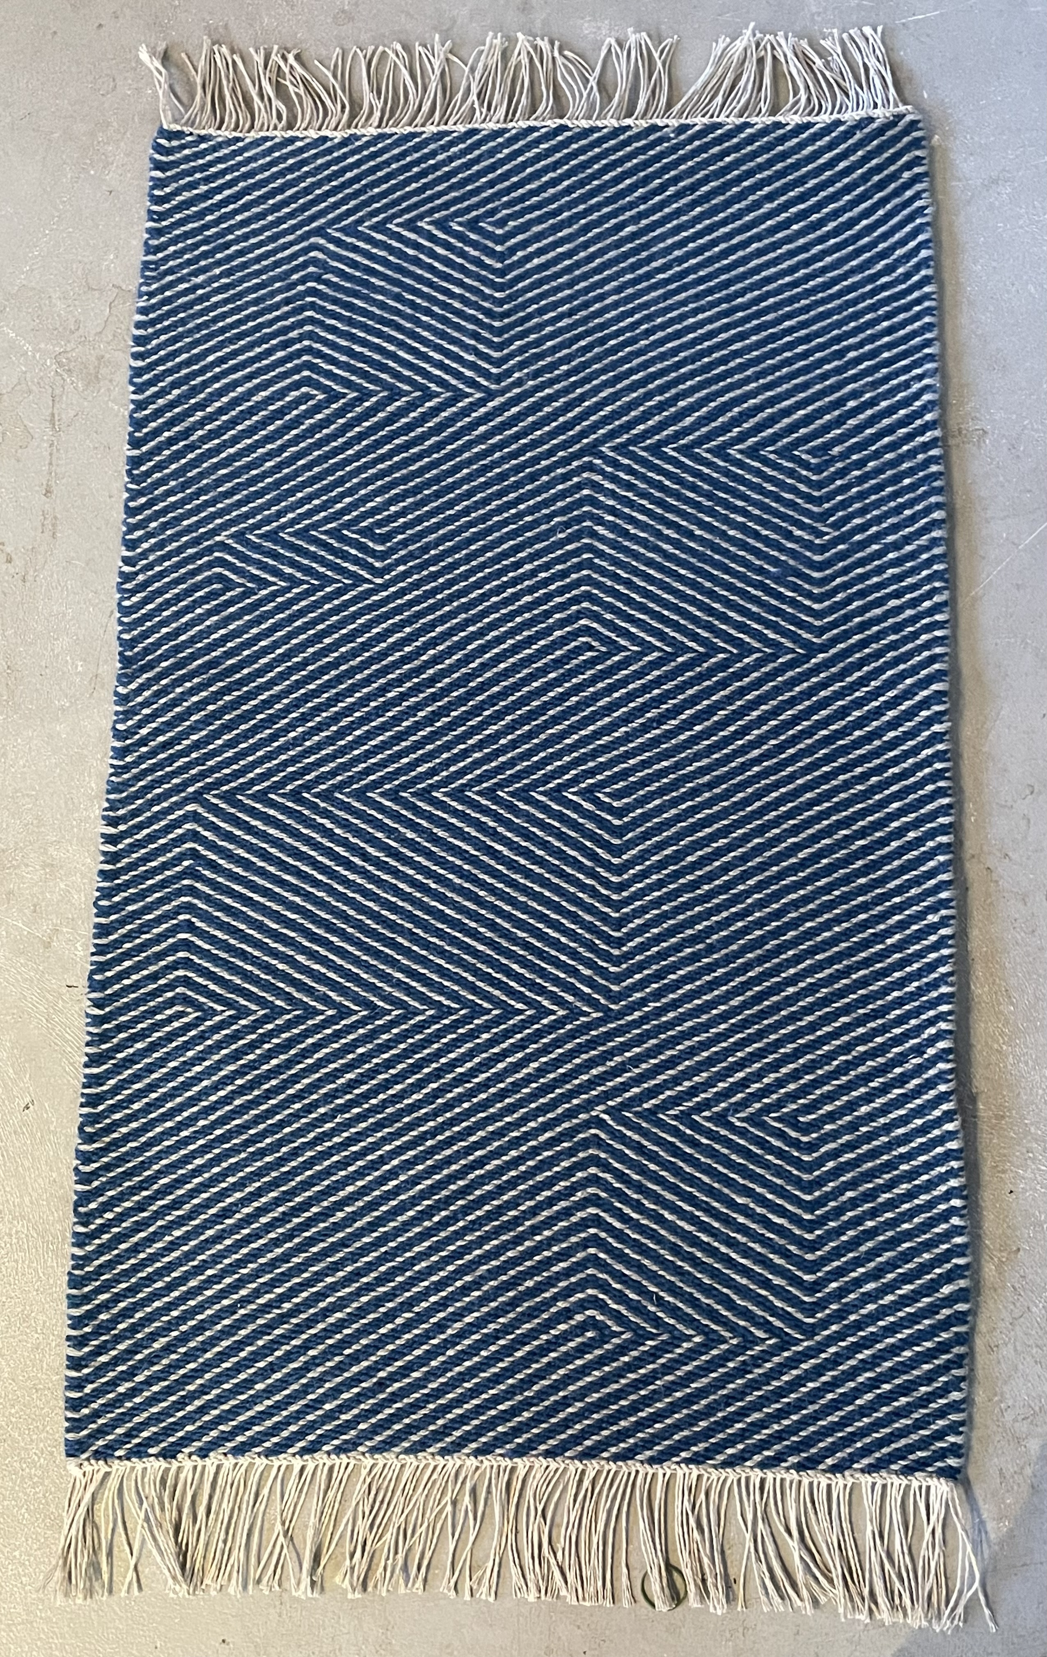
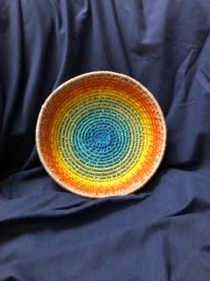
Coiled basket woven by Mary Davis for the National Parks Challenge. Her inspiration was the the Grand Prismatic Spring in Yellowstone.

Kathy O'Hern Rug for our Guild Booth at ANWG. 8/5 linen warp and Collingwood Rug Wool weft 3 strands. 2/2 twill inspired by the sky at Old Faithful Geyser in Yellowstone N.P.

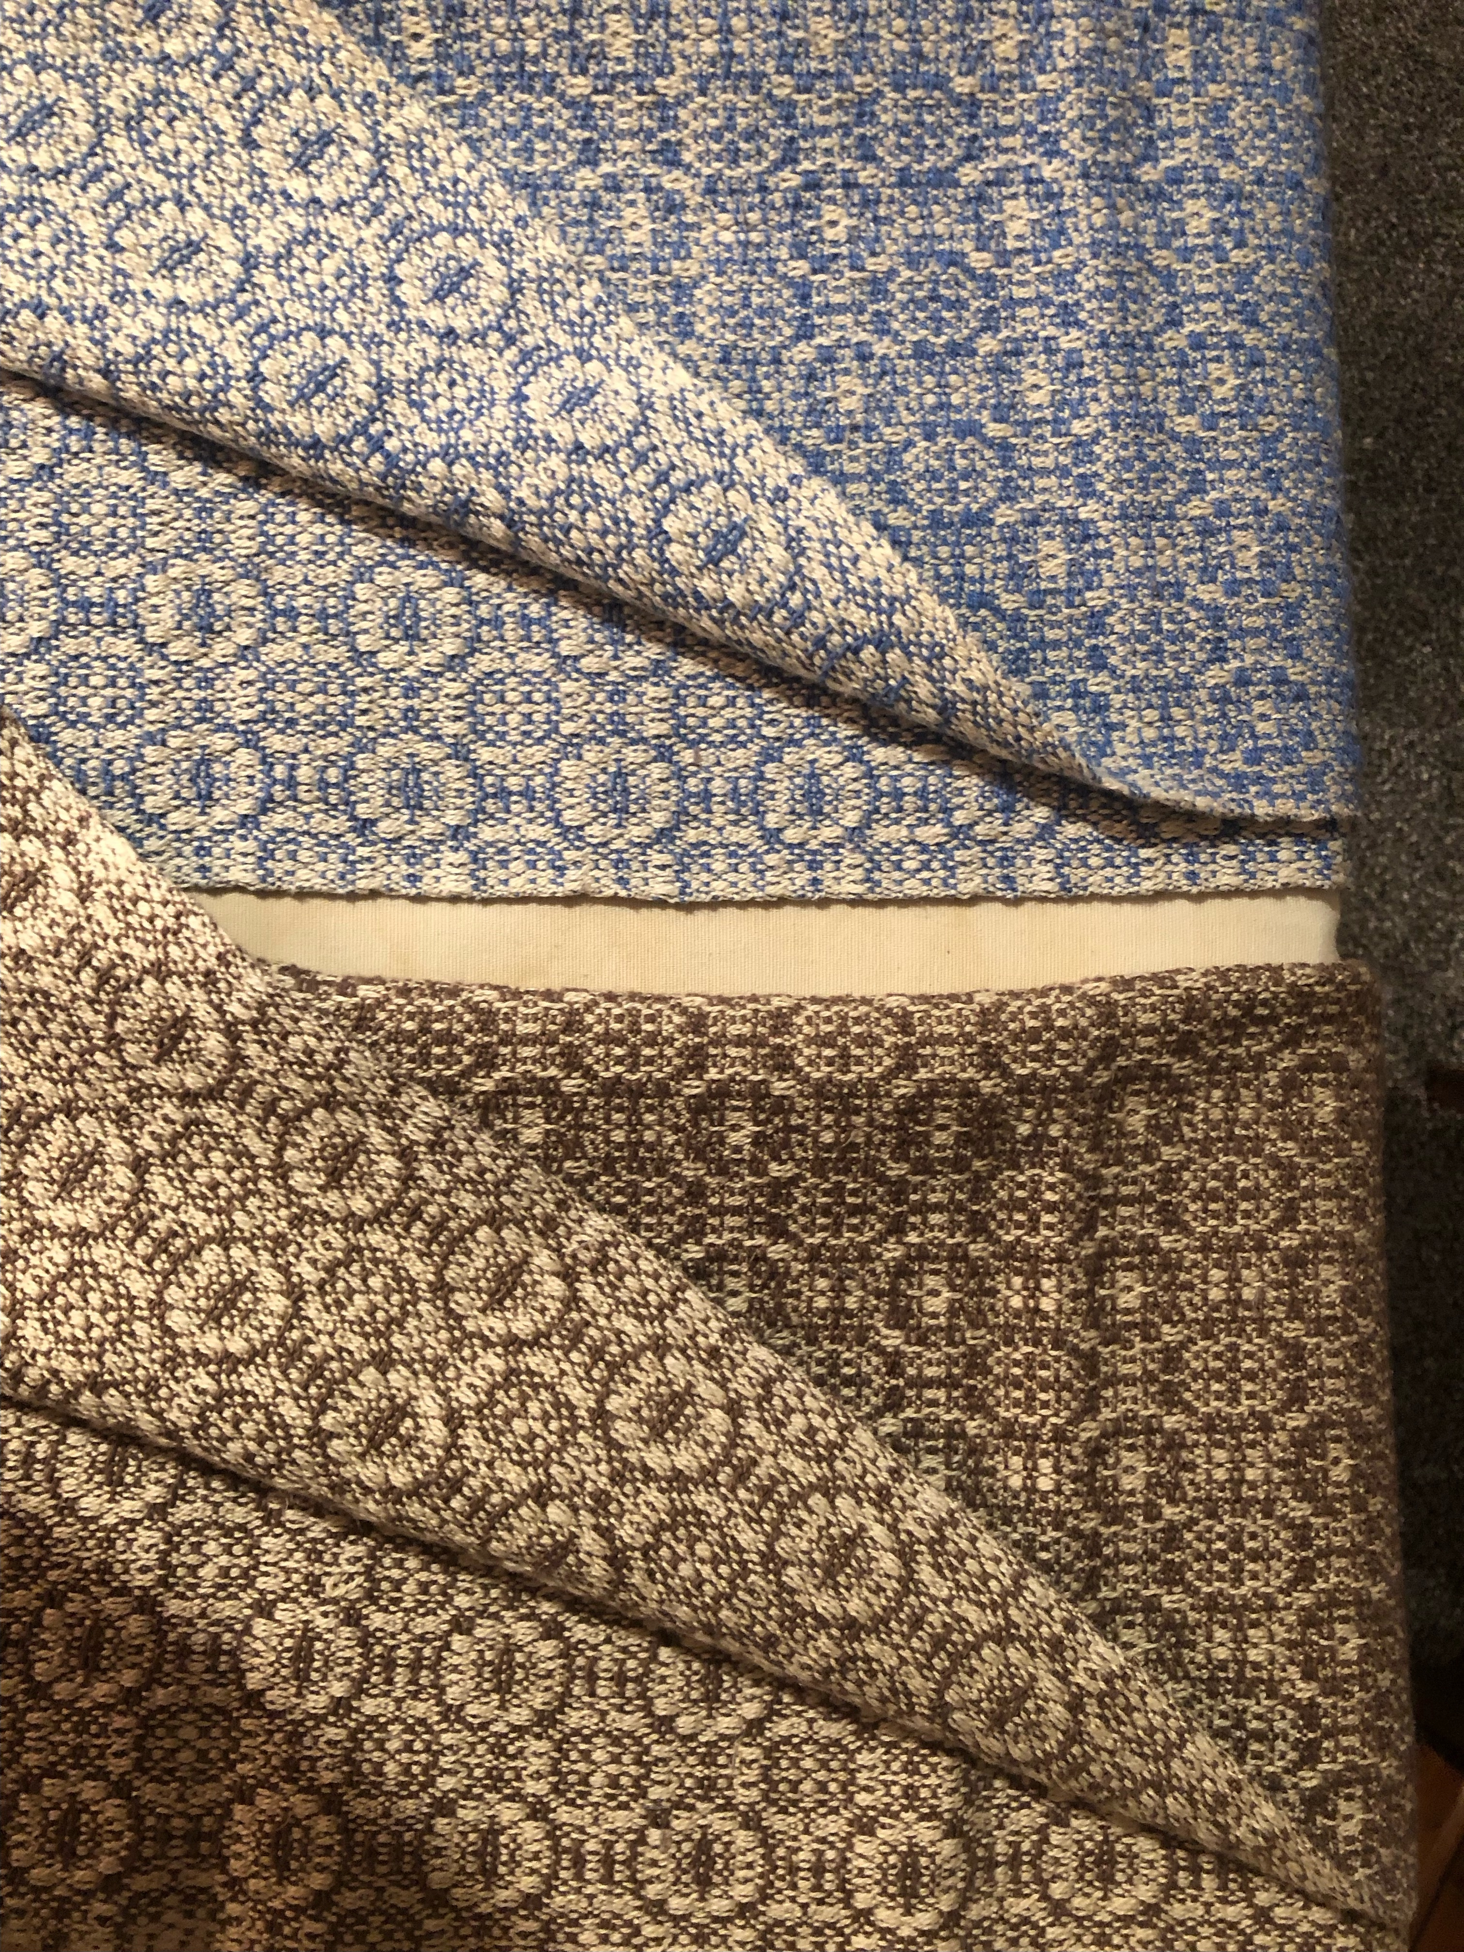
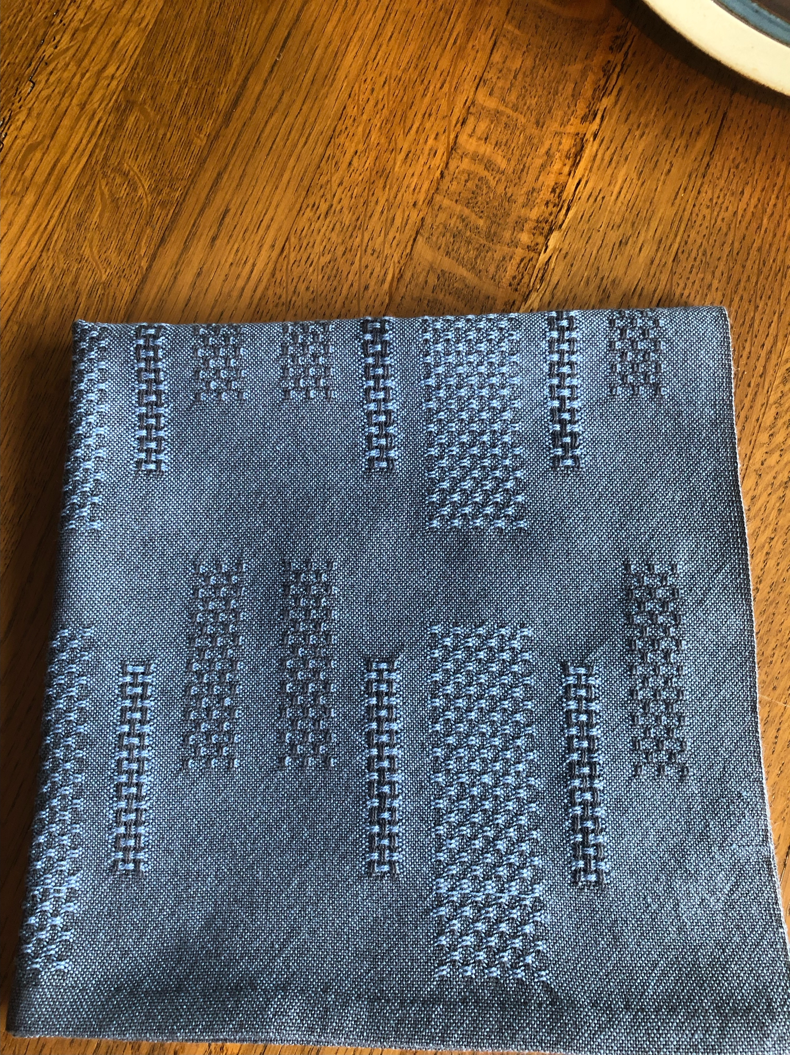
8 shaft fancy twill towels by Dottie Smith. The sides are very different. 10/2 Unmercerized cotton. Set 24 epi

Napkins are 26/2 unmercerized cotton with sett at 32 epi. Woven by Dottie Smith.

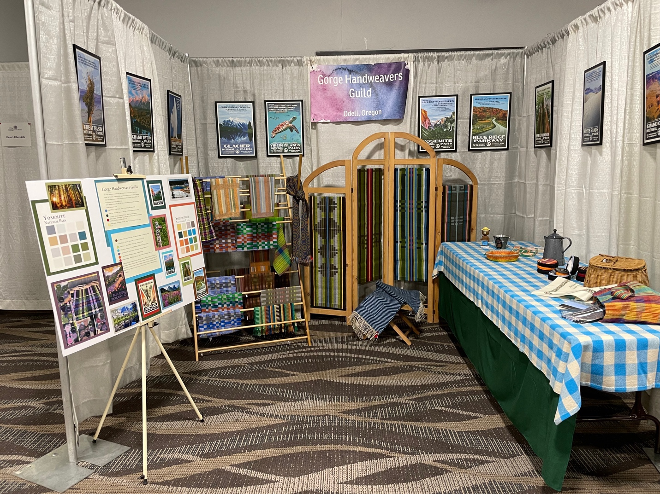
Gorge Handweavers Guild booth at the ANWG Conference in June.

