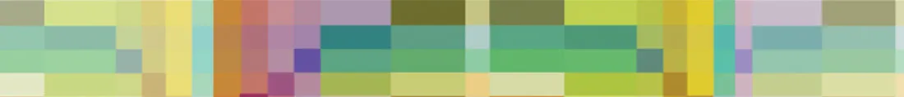
Portland Handweavers Guild (PHG)
WeGo Report for the period April 1, 2023 to September 30, 2023

PHG meets on the second Thursday of every month during September - June at the Multnomah Art Center. Morning Meetings 10am - noon, 9:30am social
Evening Meetings 7pm - 9pm, 6:30 social

April

Gathering of the Guilds
PHG had several members participate and again had a guild booth where members could sell what they had made.

Membership Meeting

Steve Grafe from Maryhill Museum – Theatre de la Mode: Paris Fashion for a Post=War World
The PHG Mannequin Project was inspired by the Théâtre de la Mode mannequins on display at the Maryhill Museum. Steven L. Grafe, Curator of Art at the Maryhill Museum of Art in Goldendale, WA will join us to talk about the history of Théâtre de la Mode, from its beginnings in 1944 to it’s influences still seen today.

May

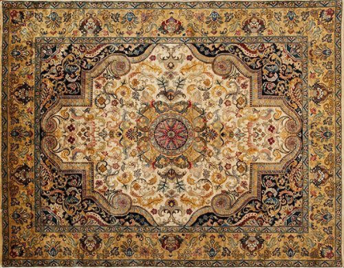
Membership Meeting
Tim Urback has been with Atiyeh for 30 years and will be presenting a program featuring the history of the company with attention to the changes in the carpet industry over these years. He will talk about the services Atiyeh provides for the public with attention paid to their work in repairing oriental pieces. There will be samples of these repairs to examine the type of work to pass around.

June

Event

Fiber Connections ANWG Conference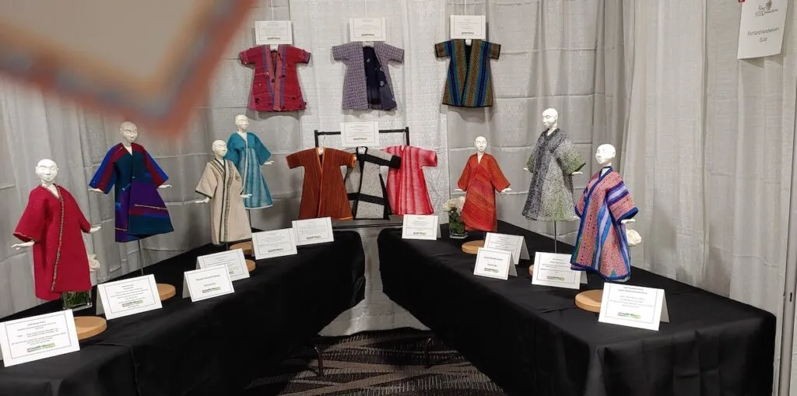
PHG was really excited about our booth win!

Membership Meeting

Strawberry Social
The evening meeting features approval of the 2023-24 spending plan, and election of 2023-24 officers and board of directors. Come socialize, and show what’s you’ve been weaving!

July – no guild meetings or events

August
Membership Meeting
ANWG Recap – So many members went to ANWG. The conference center was really nice, and everyone really enjoyed the conference.

September

Membership Meeting

Photographing Your Creations with Dave Hutt
Dave Hutt us a professional photographer and printer since 1973. He can be found online at www.davehuttphotography.com His presentation will cover using a digital camera and smartphone, composition, lighting, and printing. Come with all your questions for Q&A with a professional photographer. There will also be a hands-on portion of the program. Please bring your smartphone and digital cameras with something you’ve created to photograph.

